Network lab internal exam
fathima basheer
219

1.

2.

4.
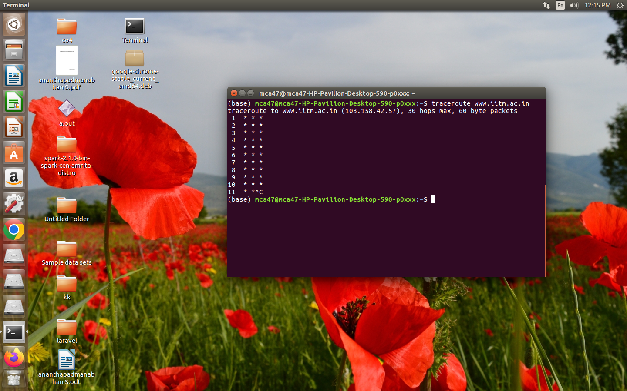

5.
a.

b.

c.

